Ideation Phase
Brainstorm & Idea Prioritization Template

Date | 03 December 2025
Project Name | Bookstore
Maximum Marks | 4 Marks

Brainstorm & Idea Prioritization Template:
The brainstorming phase helped identify and explore ideas to build a scalable and user-friendly online bookstore platform. The goal of the session was to generate creative and practical ideas that improve the shopping experience for users while enabling sellers and admin’s to effectively manage books and inventory.
This brainstorming activity encouraged exploration beyond typical approaches, allowing ideas to be freely shared, expanded, and refined without judgment. Collaboration played a key role, helping derive valuable concepts for the project vision.
This template was used to visualize the ideation process and to prioritize the most impactful and feasible ideas for implementation.

Step-1: Team Gathering, Collaboration and Select the Problem Statement
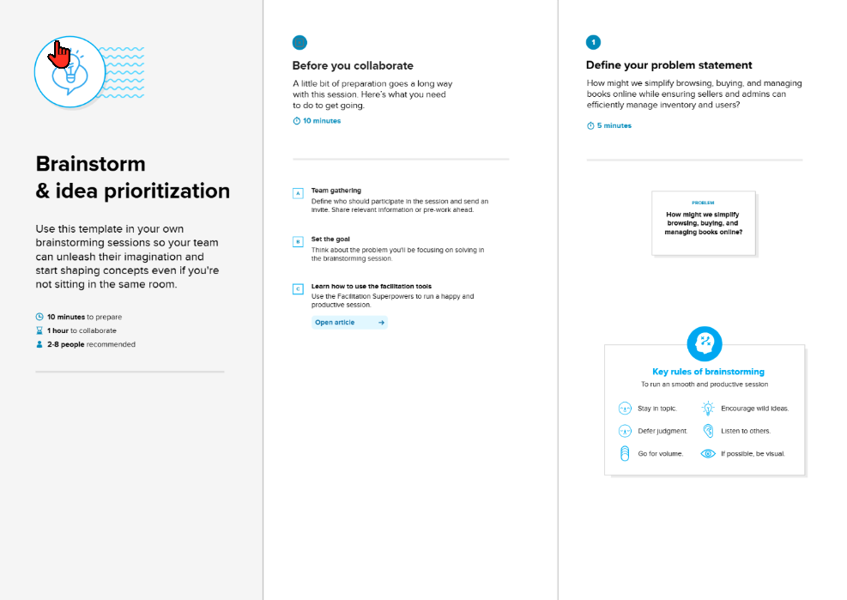

Step-2: Brainstorm, Idea Listing and Grouping



Step-3: Idea Prioritization

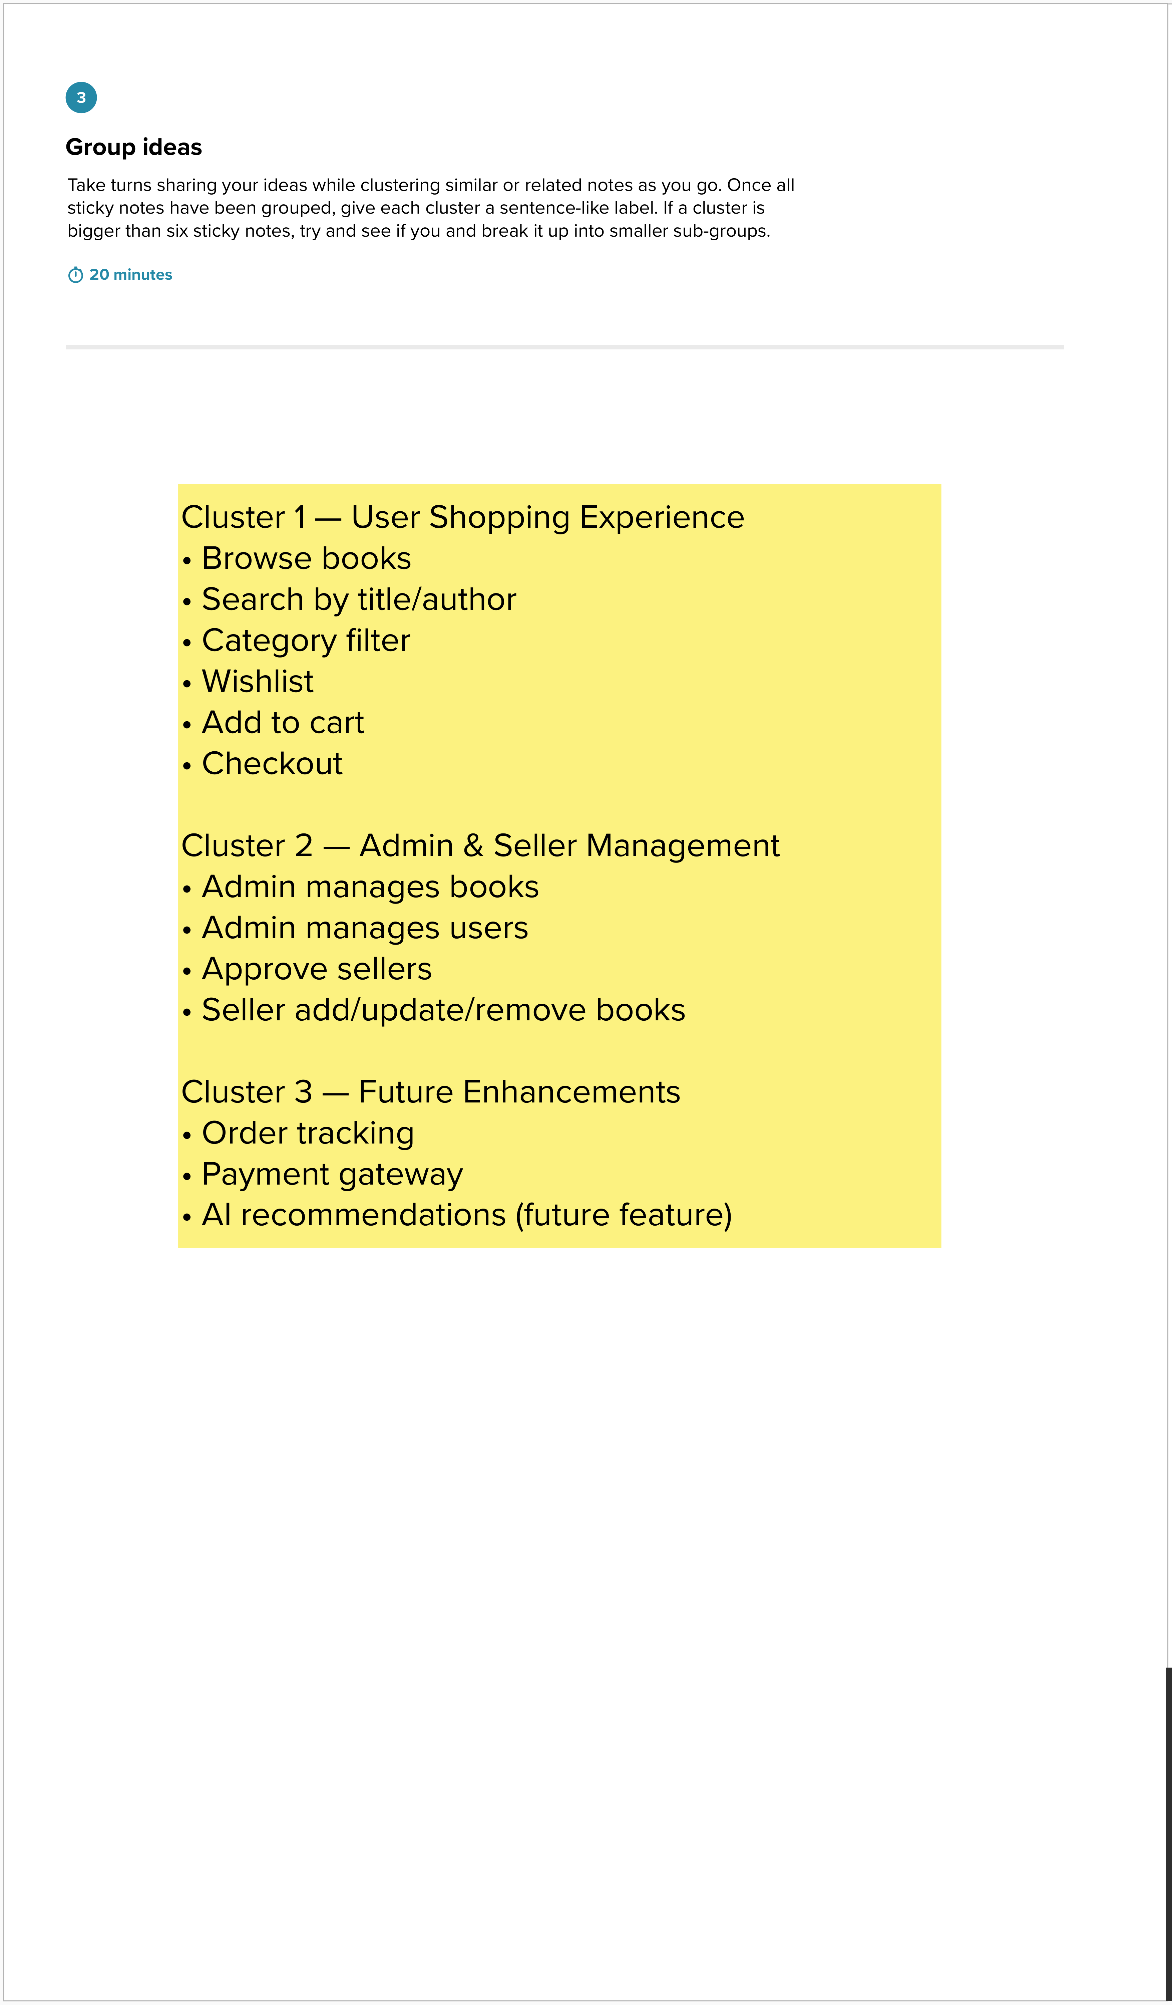

Step-3: Idea Prioritization

